2.1 Data Preprocessing and Feature Transformation

Preprocessing involved filtering records (2015–2024) and removing missing geodata. We extracted temporal features and reduced location dimensionality to the top-20 categories. Categorical variables were label-encoded, while frequency matrices underwent row-wise normalization. This enabled the comparison of temporal probabilities across crime types by neutralizing volume biases.

2.2 Comprehensive Correlation Analysis
To investigate the underlying dependencies between crime variables, we performed a stratified analysis focusing on multivariate linear correlations, temporal specificities, and enforcement efficiency disparities.
2.21 Multivariate Correlation Matrix We first constructed a correlation matrix of key features (Figure 2.21). While the overall Pearson correlation coefficients were relatively low due to the categorical nature of the data, the analysis revealed critical structural associations. Notably, the variable Arrest_Flag showed the strongest positive global correlation with Type_Code(0.20), indicating that the likelihood of apprehension depends primarily on the nature of the offense rather than time or location. Additionally, Domestic_Flag displayed a significant negative correlation with Type_Code (-0.21), revealing that domestic incidents are restricted to specific crime categories and differ distinctly from public street crime patterns. It is important to note that the near-zero linear correlation between Hour and other variables does not imply insignificance; rather, it suggests complex non-linear relationships that require further visualization.
2.22 Temporal Specificity and Non-Linear Patterns To decode these hidden temporal patterns, we generated a Normalized Temporal Heatmap (Figure 2.22), which uncovered strong temporal profiles for specific crime types. For instance, DECEPTIVE PRACTICE shows sharp spikes at 09:00, 12:00, and 00:00, aligning with business transaction hours and automated system reporting cycles. Similarly, NARCOTICS exhibits a clear bimodal distribution with activity peaks at 10:00–11:00 and 19:00–20:00, providing direct evidence for targeted shift scheduling. The data further validates classic criminological patterns by highlighting the divergence between BURGLARY, which peaks during work hours (08:00–15:00) when homes are empty, and ROBBERY, which escalates during evening hours (18:00–23:00).
2.23 Enforcement Efficiency and Business Justification Finally, we analyzed the arrest rates for the Top 15 crime types (Figure 2.23), revealing a stark dichotomy between proactive and reactive policing. Crimes like NARCOTICS (~99%) and WEAPONS VIOLATION (~65%) demonstrate high enforcement efficiency, as these are typically "proactive" offenses where police initiation leads to immediate arrest. In contrast, property crimes such as BURGLARY and MOTOR VEHICLE THEFTshow a drastic drop in arrest rates, falling well below the 20% efficiency threshold. These crimes are typically reported post-incident, placing police in a reactive stance. This efficiency gap serves as the primary justification for the Predictive Policing Model proposed in this project; since traditional reactive methods are insufficient for low-clearance property crimes, algorithmically forecasting high-risk spatiotemporal zones is essential to shift operations from reactive investigation to proactive deterrence.
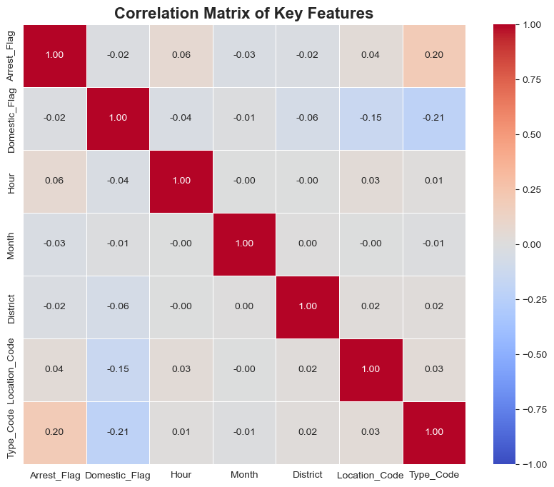

Figure 2.21
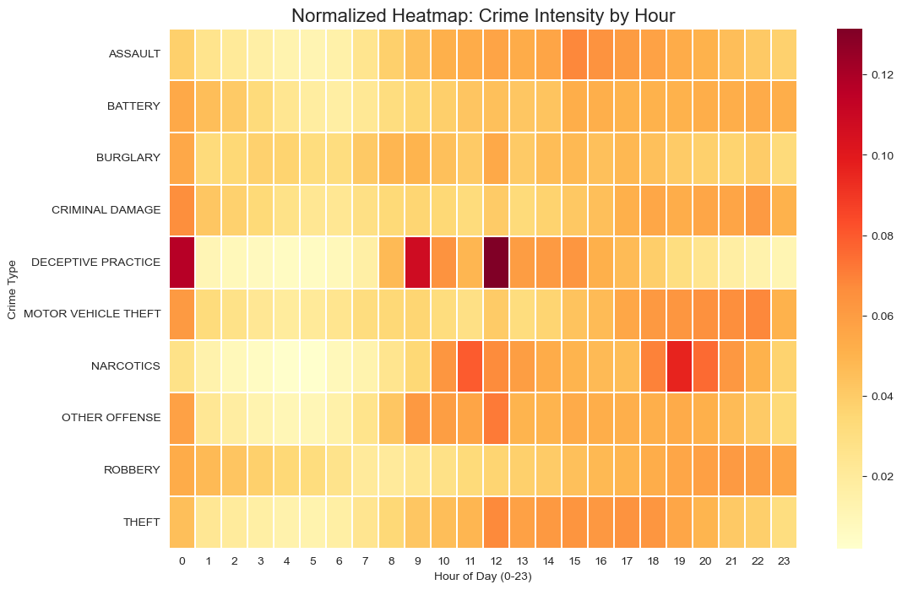

Figure 2.22
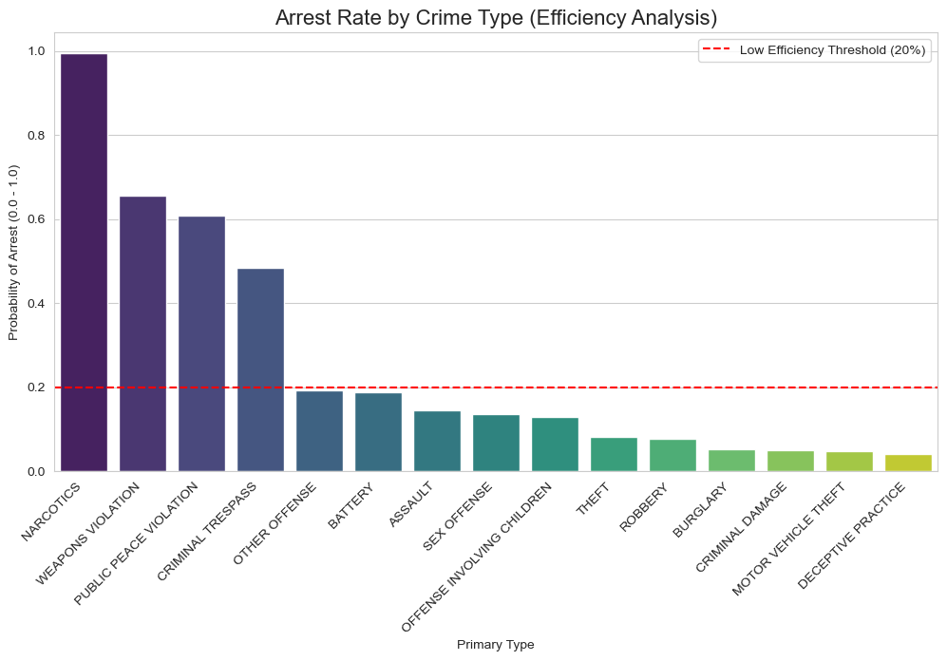

Figure 2.23

